 ‘Club’ culture
Thinks intuitively. Sees whole picture and assesses it. Moves fast to a possible solution, tests it, and moves to another if the first solution looks unsuitable. A logical step-by-step approach is not their way, for they like responding to stimulus and get bored easily. Control of resources and personal charisma that count.

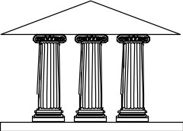 ‘Role’ Culture
Thinking is logical, sequential and analytical. Would like all events to move according to predetermined formulae. Efficiency tends to mean simplification, getting things down to the bare but essential features. Rules, systems, processes and procedures exist. The individual is replaceable and acts in accordance with organisation’s norms.

 ‘Task’ culture
The culture is the group of experts focusing on a common task or problem. Systems and methods are come and go. Problem solvers, by a mix of creativity and some applied logic. Self-development is encouraged and a movement between organisations is acceptable. Success is desirable if it has been earned. Likes variety.

’Person’ culture
Individuals are more important than the organisation. Management is by consent and a process of negotiation. They want opportunities but they have to choose. Everyone has the right of veto. Prefer to learn by new experiences. Learn from life rather than from other individuals. Like to swim out of their depth

Based on: Charles Handy, Gods of Management and Understanding Voluntary Organisations, Penguin Books.

